General Acad Policies

General Academic Policies of Ashoka University
Drafted by the Policy and Resources Department of
Ministry of Academic Affairs 2024-25
Date of Completion of Draft: 29/09/2024
Date of Approval by OAA: 10/10/2024

Notes:
- In this document, the intake year is the year used for batch specifications.
- Credit requirements for d credentials (major/minor/concentrations) are SEPARATE from credit requirements of degree (overall graduation requirements).
- This document only entails the general academic policies. Subject specific policies like cross lists, ISMs, research thesis, among others will be shared with updated subject handbooks soon.
- Please refer to the index on the left side to navigate to a particular section you wish to read.

Audit Policy
To audit a course means to attend and participate in a class without receiving a formal grade or earning academic credit. Whether a course allows audit students or the requirements of audit in a course is completely decided by the faculty.
- Auditing Courses
- Students cannot audit courses in their first semester and the summer semesters.
- From the second semester, students may audit up to two courses per semester over and above the maximum number of credits that they are otherwise allowed.
- Auditing a course does not yield credits; however, the audited course will show on the student’s transcript and require that the student submit work as determined by the faculty member. It will reflect as ‘AU’ on the transcript after successful completion of the course.
- If a student wishes to audit a given course, they must submit an audit request to the faculty through the AMS Portal.
To do this, the path is: AMS→ Course Registration → Audit Registration Form.
- Students may withdraw, without consequence, from a course that they audit by the end of Week 4. Those who drop an audit after Week 4 will get a WAU notation on their transcript.

- Credit to Audit Conversion
- If during the semester, a student realizes they wish to drop a course for credit, but still want to be part of the course and engage with it, they can request to convert their status from ‘enrolled for credit’ to ‘enrolled for audit’.
- The deadline to convert credit to audit is the end of week 8 of the semester. A student cannot convert their status in a course to auditing status past that deadline and they cannot convert any course from credit to audit if, by doing so, they will fall below the minimum credit requirements.

Note: 1) Audit to Credit is typically not allowed.
1.1) For Credit to Audit,
- If the portal is open (during the Add/Drop period i.e. First Four weeks of the semester), one can drop the course via the AMS and fill in the Audit form.
- if the portal is closed, raise a ticket via the AMS with the faculty's approval within the add/drop period.

What is Shopping Week?
Each semester has the first 2 weeks as shopping weeks (which means that you can add or drop a course without informing faculty through AMS). Please refer to the below table for a clear understanding. If you decide to drop a course between weeks 5-8, it gets reflected as ‘W’ on your transcript. If you withdraw from a course between weeks 9-14, you get a ‘W/F’ on your transcript.

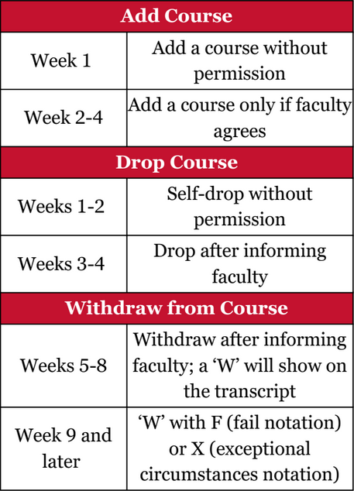

Incomplete Policy
‘I grades’ should be granted by faculty only to students who have been working throughout the semester and only near the end face sudden illness or injury, family crisis, or some other substantiated unforeseen circumstance beyond the control of the student that would make it impossible to complete all course requirements by the end of the semester. Students who are not deemed eligible may still request OAA for a WF and repeat the course at a later time. ‘WF’ has the same impact on CGPA/GPA as ‘F’ does. This request must be made in the 13 weeks of the semester i.e. last day of the class as per the academic calendar. After that, the grades decided by the Faculty will be considered as final.

- Application for an Incomplete
- Students who believe that they can demonstrate a legitimate need for an Incomplete should:
- request their faculty to grant them an Incomplete
- request their faculty to clearly specify the terms of the Incomplete

- Deadline for submitting an Incomplete
For all batches before UG2024, i.e. UG 2021-UG2023 students, the deadline for completing the process specified above is the last day of finals week of the semester.
For UG 2024, while the ideal deadline for completing the process specified above is the last teaching day of the semester, as specified in the Academic Calendar; the student must coordinate with the faculty/TF to know by when they can request for an incomplete because cases may differ if the faculty decides to conduct early final exams or otherwise.

- Conditions and Duration
- For UG 2023 and previous batches
Unless the instructor stipulates a shorter time period for completion of the work, the terms of the Incomplete must be satisfied within six weeks of the beginning of the regular semester following the semester in which it was issued.
Incompletes from a previous semester will automatically convert to an F grade at the end of week 8 (six weeks plus two weeks for grading) unless a request for an extension has been approved by the faculty and implemented by the OAA. This extension deadline must also be shared by the faculty to the student as well as the OAA.
For example, if you get an incomplete grade granted at the end of Monsoon semester, you must submit the expected coursework within the first 6 weeks of the Spring (which is the next immediate) Semester.

- For UG 2024
Incomplete must be satisfied within eight weeks of the end of the regular semester in which an ‘I’ was granted.
Incompletes from a previous semester will automatically convert to an F grade at the end of Week 8, counting from the end of that semester in which Incomplete was granted.
For example, if you are granted an incomplete grade on 13th May of spring semester (assuming that is the last day of that semester), you will have to satisfy the requirements 8 weeks from 13th May (which will go on into the summer break). Similarly, if you were granted an incomplete grade on 8th December (assuming this is the last date of the semester) of monsoon semester, you will have to submit the required work 8 weeks from 8th December, which will include time within the winter break and even into the Spring semester.

The maximum extension that can be granted is the end of the next semester, after which no further extension will be approved by the OAA and the ‘I’ will change to ‘F’. Taking the above example of 8th December (assuming it is the last day of the Monsoon semester) of Monsoon semester; even if a student gets an extension to submit their coursework for the incomplete grade till the end of Spring semester, they must submit it before the last date of Spring semester or they will get ‘F’ reflected on their transcript.

- Prerequisites and Graduation
As long as an ‘I grade’ remains on their record for a specific course, a student may not be enrolled for credit in any course which has that specific course as a stated prerequisite. Any waivers in this case have to be taken up with the concerned faculty and the OAA.

Note: A student who has completed all the graduation requirements within the stipulated time, will not be allowed to defer graduation because of the Incomplete. Such an Incomplete will be converted to a 'W' grade and the student will be marked as 'Graduated'.

Internship Policy [Last Updated based on Rules shared on 11 June 2025]
As per the four year program structure under NEP, UG2022 and further batches need at least 2 internship credits to graduate.

Credits can be earned after completing 2 full semesters at Ashoka. (You cannot earn internship credits till the end of your first year, with the only exception of UG2022. Any internships undertaken by UG2022 in their first 2 semesters will also be accepted as per the rules regarding time period defined by the OAA. )
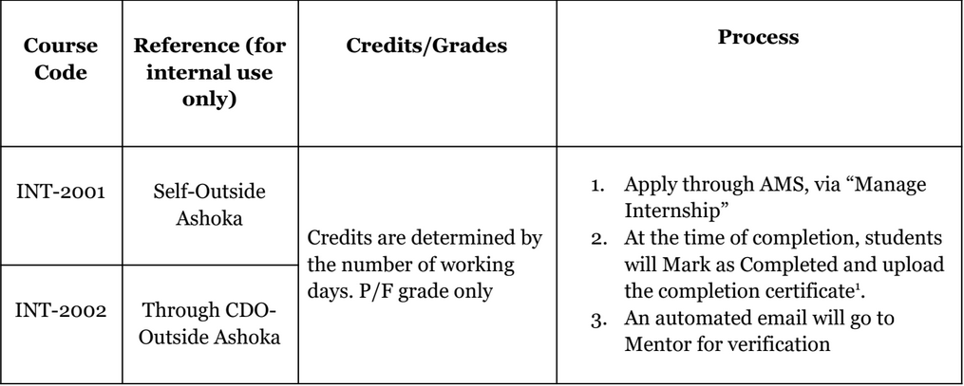
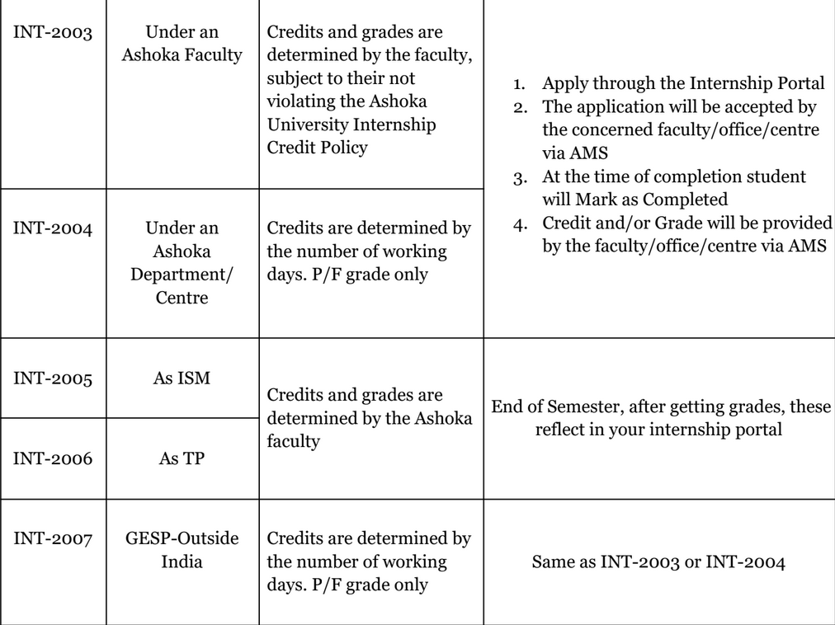
Only 2 internships with the best grades and upto 4 credits would be counted. Minimum 2 credits and maximum 4 credits will count towards satisfying NEP requirements (for 2- and 3-year exits as well as 4-year degrees) for students in the new four-year programme (joined in 2022 and thereafter).
The internships could be within Ashoka (Under a Faculty/With a Department/Centre) or outside Ashoka (Through the Career Development Office (CDO)/Self-arranged (India/Abroad)/Through the GESP Office), or a student can convert a graded ISM/TP into an internship.

Definition of internship semester as per the UG calendar:
a. If the start date of the internship lies in the Spring semester, the internship semester will be recorded as a Spring internship.
b. If the start date of the internship lies after the Spring but before the Monsoon semester, the internship semester will be recorded as a Summer internship.
c. If the start date of the internship lies in the Monsoon semester, the internship semester will be recorded as a Monsoon internship.
d. If the start date of the internship lies after the Monsoon but before the Spring semester, the internship semester will be recorded as a Winter internship.

As per the Ashoka University Internship Credit Policy, the number of credits is calculated as follows:
a. 2 Credits: Between 20 to 39 working days (Mon-Fri)
b. 4 Credits: At or above 40 working days (Mon-Fri)
Ashoka Internship Policy assumes part-time work only in the Monsoon or Spring semesters. Any internship during summer or winter break is assumed to be full-time.

Your TAship credits can also qualify for internship credits when registered with AMS. However, in this case they will only be counted once and will not count for TAship credits then.

These credits count towards credit requirements for degree and not towards any major/minor/concentration.
For example, if (hypothetically) a Pol Science TAship yields 4 credits but you want to get it registered as internship credits on AMS; then those 4 credits will not count towards your Pol Science credential (major/minor/concentration) anymore. They will be counted only towards Internship requirements in your overall credits for degree completion.

Internship credits earned during the semester will follow the maximum credit policy of that semester.
For more details about the process and rules regarding internship credit, please refer to the document shared by OAA on 11 June 2025 titled ‘Final Internship Process’.

TA Policy
Some departments consider TAship (Teaching Assistant-ship) credits for major requirements, while others don’t. Some offer 4 credits for TAship while others offer 2. The only thing that remains constant is -
- The policy says “TAship credits only count for elective credit requirements of a particular credential and can't be counted towards fulfilling the mandatory credit requirements.”
What does it mean? TAship credits (if the department counts it as part of the major) can only count towards elective credits and cannot count towards core courses/ credits. This does not mean that you cannot TA for a core course, it only means that your TAship CANNOT be counted towards your fulfilling core/mandatory course requirements, it will count towards fulfilling elective requirements.
- Secondly, whether or not your department gives you major/minor credits for doing TAship, your TAship credits will be counted towards your overall graduation requirements. (Once again, it is important to differentiate between department credits that one needs to complete their major/minor/concentration and overall credits that one needs to complete their graduation requirements).

Notable Q. Is there an upper limit to the number of TAships which can be done in a semester?
- Ans by OAA [Dated 3 Feb 2025] : Yes, maximum 8 credits.
Suggestion from MAA: Please go through FAQs in the last section of this document for TAship details as well.

The policy, benefits and credits vary across departments.

CC Policy
CC grades are like any other course grading. They are 2 credit courses. A student can take only 1 CC in a semester. All students need to do at least 2 CCs for graduation. A student can do more than 2 CCs,but only the best of two will count towards the CGPA. The credits earned by doing more than 2 CCs will not count towards the overall CGPA and the overall degree requirements.

What are Open Credits?
We know that credit requirements for degree are different from credit requirements for d credentials (major/minor/concentration). Assume that one student requires 120 credits to graduate but their major credit requirements are only 52. Now consider that the other requirements for graduation such as FCs, CCs and Internship take up another 42 credits. Still (120 minus 52 minus 42) 26 credits will be left. These are called open credits, which a student can complete doing more courses like minor, concentration among others.

ISMs Policy
An Independent Study Module allows students to delve more deeply into research, either assisting an instructor on a specific research agenda, or in some cases, charting their own research agenda. If and how many ISMs credits, shall count towards Major/Minor/Concentration requirements is decided by the department. However,it cannot be more than 8 credits. ISMs credits, if allowed by the department, generally count towards the elective requirement of a particular credential. Exceptions,if any,are approved by the Dean of the Academic Affairs.
Notable Q. Can an ISM be cross-listed?
Ans by OAA [Dated 3 Feb 2025]: ISM can not be cross listed.
Q. Can an ISM be audited?
Ans by OAA [Dated 8 Feb 2025]: No.

Retake Policy
- The retake policy allows students to retake any courses twice during the course of their 3 year program and three retakes for their 4 year program.
- For UG2022 and UG2023, those receiving a grade of below D-, which is F, will continue to have the unrestricted option of repeating the course. Those receiving a grade of D- and above will also have the option of repeating that course but can do so only thrice during their undergraduate program of 4 years. They can take 2 retakes in 3 years and 1 in the last year of their 4 degree program. Please refer to the below table for policies for all batches.
- For UG2024, if they receive a F grade, they can retake that course without it being counted in their limit. If they get a grade between C to D-, they can retake the course but they can only retake 3 courses in 4 years. They can take 2 retakes in 3 years and 1 in the last year of their 4 degree program. Unlike for UG2022 and UG2023, where the best attempt gets counted; whatever the grade of the second attempt will be, will get counted towards the CGPA for UG2024.
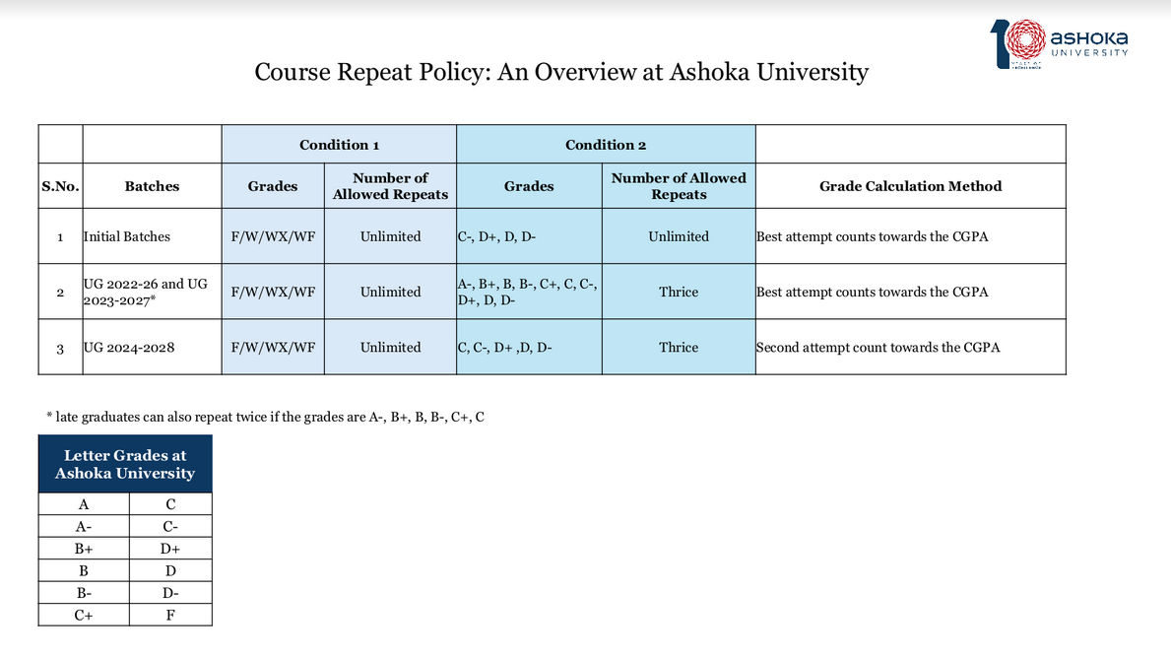
Note:
Q. Can a student transfer unused retakes from the 3 years to the 4th year?
- Ans: If a student has not taken a retake till 3 years then the student can take it in 4th year. [Reply from OAA | Dated 3 Feb 2025]
Q. What is the cap on the number of retakes which can be taken in one semester?
- Ans: There is no such cap [Reply from OAA | Dated 3 Feb 2025]

Waivers Policy
Pre-requisite courses are usually core courses for your particular major/minor degree which you need to complete before you can take higher level courses or electives. Their codes usually start with 1000 level (Eg. POL 1012) and need to be taken before courses with 2000 or 3000 level codes. While making your trajectory, please keep in mind that you need to finish your pre-requisite courses as early as possible. You can refer to the list of core courses in your respective subject handbooks, also available in the MAA Resources Folder.
There are three types of waivers-
- Prerequisite Waiver: If you're switching your major or adding a new minor but haven't done any introductory courses from that programme, you may need a waiver to take a course without the required prerequisites. However, you'll still have to complete those prerequisites in future semesters. For example, if you want to take "Intro to Literary Theory" but haven't done "Forms of Literature," you'll need a waiver, but you must take "Forms of Literature" later.
- Equivalent Waiver: If you've already taken a course in another department that covers the same material as a required course in your new major, you can get an equivalent waiver, meaning you don't need to take the same course again. For example, if you've completed "Stats for Economics," you can waive "SRM I" in Psychology.
- In Lieu of Waiver: If you're struggling with a required course or can't complete it on time, you can request to take a different course as a substitute. The alternative is chosen by the department head and could be another core course or an Independent Study Module (ISM). This, however, is a rare case waiver and completely depends on departmental and Dean’s approval.

Grade Appeal Policy
A student can appeal only the final grade of a course under certain circumstances.
The instructor’s academic judgment about the quality of a student’s work is not negotiable.

- An appeal may be made if the student can show that the grade grossly violates the instructor’s grading policy or was awarded in a manner that is arbitrary and discriminatory.
- Calculation error is a valid ground for appeal.

Grade appeals submitted for any other reasons, like some mentioned below, will be

Could be DECLINED because of:

- Because the student judges that their grade does not reflect how hard they worked.
- Because the course instructor denied them an academic accommodation that impacted their grade (barring academic accommodations approved by the Office of Learning Support).
- Because their CGPA falls below a threshold necessary for admission to another Programme.

To lodge a grade appeal, students must use the Grade Appeal Portal on AMS and provide all the necessary information. They must provide a complete explanation of the error in their grade: for example, they can document the grading rubric of their course by submitting a copy of the exam/syllabus or evidence for the grading rubric communicated to students elsewhere; or give a detailed and specific explanation of the error in their grade.

They must submit their grade appeal through the Grade Appeal Portal within the prescribed deadline shared by the Office of Examinations and the Office of Academic Affairs (OAA) through mail earlier.

A committee consisting of the Head of the Department, the Controller of Examinations and the Dean of Academic Affairs will evaluate all appeals. There is no fixed deadline for results of the grade appeal unless d by the Office of Examinations over mail.
Please note that the Committee's determination is final and binding on the student, and that their grade may remain the same or be higher or lower.
If a graduating student makes a grade appeal, in case the grade gets revised, the transcript shall get revised later on.

Note: For any queries regarding grade appeals, you must write to the Office of Examination and not the OAA.

Leave of Absence Policy

Exceptional circumstances, such as health- or family-related difficulties may arise in which a student takes their best option, that of taking a leave of absence (LOA).

- An LOA must always be requested and can only be granted for one full semester only.
- If the request for an LOA is received within eight weeks from the start of the semester and if the request is subsequently granted, the OAA will update the student’s semester status to LOA, remove the student from all the courses they are enrolled in and inform the student’s professors. As a result, the semester will disappear from the student’s transcript.
- If the request for an LOA is received after eight weeks from the start of the semester and if the request is subsequently granted, the semester will not be removed from the student’s transcript. The OAA will withdraw the student from all courses with a WX grade and inform their professors about the LOA.
- If, before the point in time a request for an LOA is approved (or after, such as in case a decision on an alleged Academic Integrity Violation is pending,) a final grade has been given to the student for a course in the semester for which the LOA is requested, then even if the LOA is granted, that final grade will stay on the transcript.
- An LOA is usually not granted during the first semester.
- An LOA must be requested no later than the last day of the semester.
- To request an LOA, the student must send an email intimating their request and providing their reasons for their request to the OAA. The student’s request must be supported by an email from a parent or guardian.
- Not more than four LoAs may be granted to a student during the UG program. In addition, not more than three LOAs may be granted to a student during the first three years of the UG programme.

Maximum Credit Policy
Standard for all cohorts: UG students will be allowed to do a maximum of 16 academic and 2 non-academic credits in their first semester, and 22 academic and 2 (CC/Internship credits) in the following semesters, except in either the 5th or the 6th semester, and in either the 7th or the 8th semester, where students will be allowed to take a total of 26 credits (including CC and Internship).

Overall Credit Requirements

As mentioned above, overall credit requirements are graduation requirements which are separate from major/minor/concentration requirements. It is the minimum number of credits a student needs to graduate (which is constant irrespective of the major/minor/concentration that they are pursuing), this includes credits from your d disciplines, your FCs, CCs, TAship, ISMs (if any) and internship credits.

For UG’2022 and UG2023
OVERALL GRADUATION REQUIREMENTS is 114 Credits for three years and 150 Credits for four years.

For UG’2024
OVERALL GRADUATION REQUIREMENTS is 120 credits for three years and 160 Credits for four years.

Batch | Duration of Program | Total Number of Credits to Graduate
UG2022 | 3 years | 114 credits
UG2023 | 3 years | 114 credits
UG2024 | 3 years | 120 credits
UG2022 | 4 years | 150 credits
UG2023 | 4 years | 150 credits
UG2024 | 4 years | 160 credits

Fourth Year and FCs
All students must complete 9 foundation courses before they graduate.
As per the existing policy, if a student plans to pursue a four year degree instead of three, then they are technically allowed to take FCs in their last year BUT the OAA strongly advises students to complete all FCs by their third year because they are planning to introduce a system that will prioritise first and second years for FC courses in the near future. Whilst it is still technically allowed to take FCs in the fourth year, this system will make it more difficult for fourth year students to get seats in FCs.

OAA Student Trajectory Report
Every year, the OAA sends a trajectory report to third year students, which is a very detailed and technical record that shows the different credit requirements and degree rules that a student needs to fulfill while abiding to all the gateway, core, elective and cross-list policies. It basically sends an individual report based on your d major/minor/concentration and explicitly tells you what credit requirements you have MET and NOT MET and if you have violated any policies that might prevent you from graduating on time. It is to help the students plan their next semester accordingly. The report for UG25 students will be published this November/December, however the OAA shall try to publish reports from the next year by June, so students get at least 2 semesters to take any imperative courses that they need to.

Pass Fail Policy
UG2022 and UG2023 can use up to 2 pass/fail options in the first three years and 3 in the four year programme for any academic course. If a student opts for pass/fail, in the d time period by OAA over email, their letter grade will appear as P or F on the transcript. The credits for that course will be counted but the CGPA will not be affected by that course.
For UG2024, this option does not apply. They can only avail P/F in internship credits, the details of which were mentioned in the internship section.
Note:
- Taking a Pass grade during your undergraduate program WILL NOT disqualify a student from Latin Honors if the final CGPA is equal to or above 3.60.
- A Pass does not have any impact on the CGPA calculation.
- For UG2022 and UG2023, if you have one or more unused P/F from your first three years, they can be carried forward to the 4th year. However, a student cannot use more than one P/F in one semester.

Study Abroad Credits
A student cannot go for a semester abroad in their first year. If any student goes to study abroad either in a semester or for summer, they need to be approved by GESP. The courses they wish to take should be registered on AMS under the Study Abroad tab, and should be approved by the department HODs for credit transfer to be possible. The grades for such courses are not transferred and only credits get counted towards your d credentials.

Research Credits
How do research credits work? A student planning to do a 4-year degree in research has to earn 12 credits from the research from their chosen Major, which will be over and above the Major credits for 4-year degree. The process around this will be communicated by December by the OAA. This document will be updated with a detailed policy interpretation based on the communications from OAA’s side.

Type A and Type B Majors
All credentials which qualify as Majors in Ashoka are classified into type A and type B majors. They have differences in the subject wise number of credits which you are supposed to complete to complete your major. Eg. If you are doing a 3 year degree from the UG2023 batch, you need 114 credits to graduate (these are the overall graduation credit requirements inclusive of FCs, CCs, internship credits et cetera). But among these 114 credits, if you are a type A major you will need a minimum 52 credits for a three year degree while a type B major will need minimum 60 credits for a three year degree.

The current list of type A and type B majors for ALL COHORTS is attached below.

S. No | Majors | Type
1 | English | Type A
2 | History | Type A
3 | International Relations | Type A
4 | Philosophy | Type A
5 | Political Science | Type A
6 | Psychology | Type A
7 | Sociology and Anthropology | Type A
8 | Biology | Type B
9 | Chemistry | Type B
10 | Computer Science | Type B
11 | Economics | Type B
12 | Mathematics | Type B
13 | Physics | Type B
14 | English & Creative Writing | Type B
15 | English & Media Studies | Type B
16 | English & Performing Arts | Type B
17 | Mathematics & Computer Science | Type B
18 | Economics & Finance | Type B
19 | Economics & Public Policy | Type B
20 | Economics & History | Type B
21 | Computer Science & Entrepreneurship | Type B
22 | Psychology & Philosophy | Type B
23 | Philosophy & Computer Science | Type B
24 | History & International Relations | Type B
25 | Politics, Philosophy and Economics | Type B

The detailed list of every major with their split up credit requirements will be provided in the subject handbooks.
The Minimum credit requirements for UG2024, based on Type of Major are: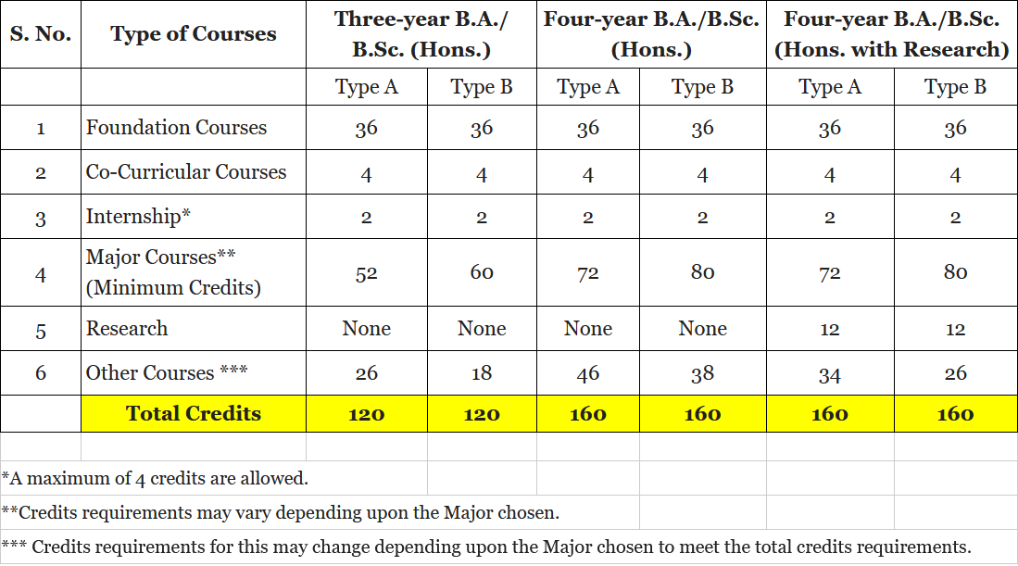

The Minimum credit requirements for UG2022 and UG2023, based on Type of Major are: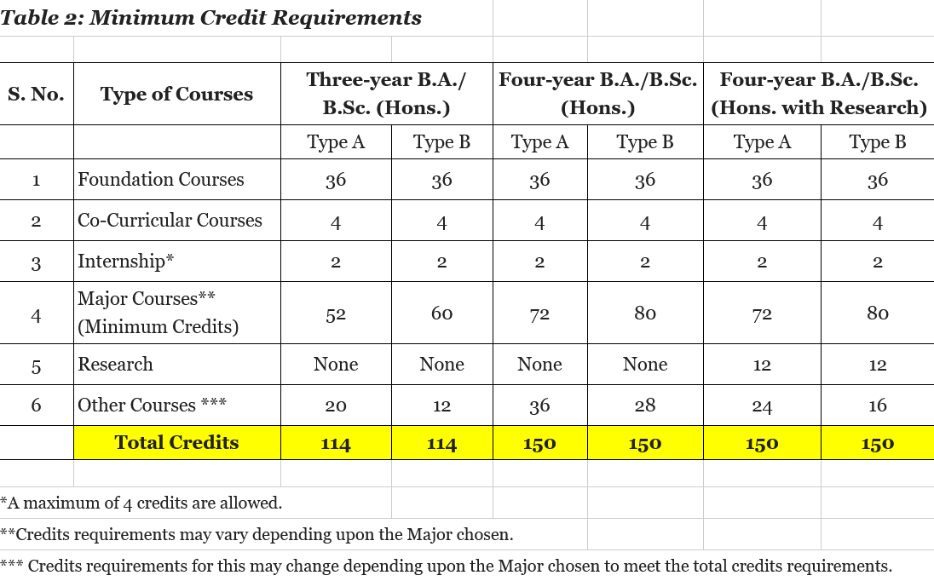

General Cross List Process Interpretation
Terminology:
Dept A xxxx/ Dept B yyyy
Department A is the parent department/ originating department
Department B is the child department
So the course will be considered as a cross-list in your trajectory if you want it to be counted towards department B, because it is being offered by department A. For any course to be cross-listed, there must be written approval of both the HODs of the concerned departments which reflects as approval on AMS.

For eg-
POL- 3042/ ENT- 2067
POL is the parent department
ENT is the child department
For POL, the course will not be considered as a cross list but for ENT it will be.

What if you want it to count towards both ?

If Dept A and Dept B are your major/minor/concentration, it will count towards fulfilling BOTH your credit requirements of major/minor/concentration but it will count only once in your overall graduation requirements.

This is because credit requirements for d credentials (major/minor/concentrations) are SEPARATE from credit requirements of degree (overall graduation requirements).

In POL- 3042/ ENT- 2067, this course will count towards both POL and ENT, and fulfill your major and minor credentials. BUT, you will be one course, i.e 4 credits short of meeting your graduation credit requirement, because instead of doing two separate courses, you’re doing one. That means that a student,who has 8 credits left (for example) to complete the overall credit requirements,will have to take one more extra course of 4 credits,if he takes a cross listing course. This means that you may complete your major and minor but you still won’t be able to graduate because you have not completed the credit requirements in total. Hence, in order to graduate you will to complete the leftover 4 credits by taking up any other course of your choice - this course need not be POL or ENT, because the cross-list course has already granted you your major and minor, so you are free to explore any other course or discipline, the only goal is to complete four more credits to fulfill your graduation credit requirements.

POL- 3042/- ENT 2067 | Pol Credits | ENT Credits | Total Degree Credits
Credits | 4 | 4 | 4 (not 8)
Counted for Cross List Limit | No (because it is the parent department) | Yes (because it is the child department)

Note: Please read the limitations on cross list policy mentioned below.

What happens in the case of interdisciplinary (ID) majors ?
In the case of ID majors, a cross-listed course can only count towards one of the departments of the ID major they have d, and NOT BOTH. Unlike the previous example of major and minor, where a cross-listed course counts towards both departments, in an ID major, a cross-listed course can count towards only one, and the student can choose which department they would like the course to be considered for.

Let’s say you are pursuing an English and Media Studies Interdisciplinary Major.

For Eg- MS- 2031/ ENG- 2005
Then you can count it towards English OR Media Studies and NOT BOTH. Hence, to complete this ID major and taking a cross-list course does not decrease the number of courses you have to take for the major.

For Eg- ENG-3051/MS-3065/CW-3000
Since you are pursuing English and Media Studies ID Major, it will count towards either credits for English OR Media Studies. However, if creative writing is your minor or concentration, it will count for credits separately for creative writing in your minor/concentration tally. CW here will be treated as a cross listed child department in the same way as it is done for non-ID majors.

The student will also have to account for their overall graduation credit requirements, and ensure that they complete the total required no of credits to
1- Complete their major
2- Complete overall graduation requirements (FC requirements, CC requirements, Internship requirements and maintaining a overall CGPA of 1.67 ; also by taking up random courses or pursuing a minor/concentration)

What does it mean to violate the cross-list policy ?

It basically means you have exceeded the number of cross-list courses that your department allows you to take, and hence you are not meeting your major/minor/concentration requirements. (Once again, it is important to remember that if a course is being offered by the department you are pursuing as a major, then it is not a cross-list).

Let’s say department A allows a student to take a maximum of 2 cross-lists to fulfill a major in A. But a student takes 3 instead. Then, only 2 out of the 3 courses will be counted towards their major, they would have to take up another course being offered by their own department, in order to fulfill their major requirements. The logic would remain the same, if the student is pursuing a minor or concentration in Department A instead of a major and they exceed the cross-list limit. The cross-list limit varies across departments and also differs with respect to what you are pursuing- major/minor or concentration. This may also result in not graduating on time.

Note from the Policy & Resources Team, Ministry of Academic Affairs 2024-25
The entire purpose of this document has been to create a one-stop go-to resource for undergraduate students of all cohorts to know ALL their UPDATED academic policies. We hope that through this document you not only receive policy specifications but also important interpretations and guidelines which will help you through your academic journey. We encourage you to review these policies thoroughly and use them as a resource through your years. You are always welcome to come and recheck all information through your UG handbooks, the collection of which is available on this link.
We would also like to extend our sincere thanks to Pritika Ma’am and the Office of Academic Affairs for their invaluable support and expertise in helping us craft these policies. Their collaboration has been essential in ensuring that these guidelines meet the needs of our academic community.
In case of any questions, the Office of Academic Affairs and the Ministry of Academic Affairs are available to offer further guidance and assistance. OAA is available for office hours during the weekdays on the first floor of the Admin Block. You can reach out to the Ministry by writing to us over email (academicaffairs.ministry@ashoka.edu.in) and we will be happy to meet and connect with you.
As the drafting team, we trust that this document has provided valuable clarity and guidance. We appreciate your time in reviewing it, and we are confident it will serve as a useful resource moving forward.
Thank you!

Some Additional Questions and Clarifications:
Disclaimer from OAA: The replies are based on prevailing policies.
Q. For students who opted for P/F, does absolute grading affect their P/F or will the professor's individual grade boundaries decide the same?
Reply. On the basis of grade boundaries professors decide the final grades and as per policy D- or above grade reflect Pass grade and F considered as Fail grade. [Reply from OAA | Dated 19th Dec 2024]
Q. Can students (UG25, UG2023 and UG2024) take CCs in their 4th year as well, if they are doing a 4 year program?
Reply : Students have to complete four credits from CC during the UG programme. They can take CC courses in any semester depending on availability. Generally CC classes happen on the same timings so practically it is not possible to complete both CC courses in the same semester. [Reply from OAA | Dated 19th Dec 2024]
Q. If a UG25/UG2023 student retakes a course and uses P/F and gets a P on that course; since as per policy, the better grade is counted; will P be considered the better grade or the one in the first attempt (provided it was above D)?
Reply: If you retake a course and opt for P/F and get P in that course then it will not affect your gpa/cgpa. Once you get a P in a course then you cannot repeat it. [Reply from OAA | Dated 19th Dec 2024]
Q. For UG2024, who did not have ICT this semester, do they need to pre-register and register for an ICT course in spring sem or will it be pre-allotted? Please explain the procedure.
Reply: It will be pre allocated. In case, students wish to change the section they can do so through the registration process. [Reply from OAA | Dated 19th Dec 2024]
Q. What is the policy for failing an audit course? What grade appears on the transcript if a student fails to meet the audit requirements?
Reply: WAU appears on transcript if a student fails to meet audit requirements. Failing an audit course depends on the criteria set by the course instructor. [Reply from OAA | Dated 19th Dec 2024]
Q. What is the maximum number of the courses you can pre-register and register for? (registration rules)
Reply : There are two categories in pre-registration. First is Opt IN, you can opt in for maximum allowed credits for that semester. Second is Register Interest, you can register interest for 10 courses. [Reply from OAA | Dated 19th Dec 2024]

Q. How to register TAship credits as internship credits?
Reply: You can register the TAship as an internship via the TP registration portal. We will ask students in October if they want their TAship to count as a TAship or an internship. This can count as either TAship credit or internship credit. [Reply from OAA | Dated 9 Aug 2024]

Q. If one gets a fail grade after opting for a P/F, will revaluation lead to a conversion to Pass grade (incase of upgrade) or to a letter grade?
Reply: If a student gets a grade between A to D- after revaluation, it will show as 'P' on the course report. [Reply from OAA | Dated 9 Aug 2024]

Q. If one retakes a course after taking P/F (if they have failed), will they only get P or F in the next semester or can they opt for a letter grade?
Reply: In case a student gets an 'F', upon retaking the student will get a letter grade. [Reply from OAA | Dated 9 Aug 2024]
Q. OAA had shared this folder as 'graduation rules'. Could you please confirm if this is the most updated one yet? It's been widely circulated and hence we wanted to check in with the office if this is the latest one.
Reply: Yes, it is updated as of 3rd Feb 25 [Reply from OAA | Dated 3 Feb 2025]

Q. If a student opts to do the thesis in the fourth year, which is for 12 credits, then what is the cap on the number of courses we can take on both semesters that year?
Reply: It depends on the department [Reply from OAA | Dated 3 Feb 2025]

Q. Can students who have audited a course in one semester, retake the same course for credits in upcoming semesters?
Reply: Audit course will not be considered as a retake. Student can register for the course but it will not be counted as a retake [Reply from OAA | Dated 3 Feb 2025]
Q. For a minimum 16 credits in a semester, can TAship credits be used to fulfill them instead of 4 courses? Or does it compulsorily have to be 4 courses as well?
Reply: yes, TA ship credits can be considered. [Reply from OAA | Dated 3 Feb 2025]

Q. If a student retakes a course and takes PF and gets P, will the initial grade stop being calculated from the CGPA?
Reply: Yes, subject to batch specific policy. [Reply from OAA | Dated 8 Feb 2025]

Q. Can ASP retake courses from the first 3 years?
Reply: No [Reply from OAA | Dated 8 Feb 2025]

Q. Once you have taken a course as an audit, does it mean you have completed the course as a pre-requisite for later courses?
Reply: Depends on department, but in most cases: no. They will have to take it for credit. [Reply from OAA | Dated 8 Feb 2025]

Q. Can a student do more than one TAship in a semester from the same department?
Reply: Depends on department [Reply from OAA | Dated 8 Feb 2025]

Q. Can a student do more than one TAship in a semester from different departments?
Reply: Subject to max credit limit of 8 credit in a semester. [Reply from OAA | Dated 8 Feb 2025]

Q. Does WAU impact CGPA?
Reply: No [Reply from OAA | Dated 8 Feb 2025]

Q. What is the difference between WX and WF?
Reply. WF implies a fail grade and has the same effect on CGPA as a F; while WX does not impact the CGPA. There is no formal provision for getting WX. It is granted in very rare situations (for eg. might be given in the case of a rare LOA) [Reply from Priyesh Sir, OAA–Verbally | Dated 30 April 2025]

Q. Does CGPA get affected by internship grades?
Reply. If the student is doing an internship within Ashoka with a centre or an office, they will received a P or F grade and the CGPA will not be affected. If a student is doing an internship outside ashoka, they will receive a P or F grade and the CGPA will not be affected. However, if a student is doing an internship with a faculty or wants their ISM or TP credits to be counted for internship, they will receive a letter grade for it which will affect their CGPA. [Reply from Priyesh Sir, OAA–Verbally | Dated 30 April 2025]
Q. What happens when faculty flags you for academic dishonesty?
Reply. Your case gets sent to OAA from faculty. If you wish to contest the case, the OAA will send your case to a committee where proper hearing will be made. If you have had previous flags before, your case will directly be sent to the committee. [Reply from Pragya Ma’am, OAA–Verbally | Dated 1 May 2025]
Q. Does TA-ing for YSP/LGP count towards TAship credits? If yes, how do we go about registration for the same?
Reply. YSP or LGP does not count towards TAship credits; however, you may register them as internship credits. The office will send the details for the registration process soon. [Reply from Pragya Ma’am, OAA–Verbally | Dated 1 May 2025]
Q. In the case that an incoming student wants to transfer to a foreign university, they would only be able to do so after their second year as the credits from FCs are not transferable, right?
Reply. For transferring to another university from Ashoka, students just exit the university by the due process, it is the other university who will follow their process of credits transfer according to their norms. [Reply from Pragya Ma’am, OAA–Verbally | Dated 7 May 2025]
Q. Can I audit a course I've already completed?
Reply. Yes, you can [Reply from OAA | Dated 2 June 2025]
Note from MAA: Please reach out to OAA on a case by case basis to know how exactly the credits will work for such a case.
Q. If I mark my ISM for internship credits, does it still also count as an elective I have completed?
Reply. No [Reply from OAA | Dated 2 June 2025]
Q. Is there any limit as to how many TAships you can do during your time at the University? Or is it just the credit limit per semester of 8 credits?
Reply. The maximum number of TP credits allowed will be 4 for their degree [Reply from OAA | Dated 2 June 2025]
Clarification: This means that 1. If a student gets TAship credits in a major, the 4 will get counted there. No additional TAship credits allowed in major or minor or open credits. 2. If a student gets credits in minor, the 4 will get counted there. No additional TAships in minor or major or open credits allowed. 3. If a student's TAship does not get counted in major or minor, max 4 credits can be counted as open credits in overall degree. A student should check with the department to know what is the limit of credits allowed for their particular department and also if the TAship yields any credits at all, and if so, how many. This may vary based on department. [Clarification from Vinay sir, OAA | Dated 3 June 2025]

